**Log4j**

* Framework by Apache for logging java.
* Logging offers quick debugging, easy maintenance and structured storage of application run time information.

* we must initialize one logger object for each java class, Log4j provides factory method to generate logger objects. By using logger methods, we generate log statements.

**Log Levels:**

**Log Level Order:**

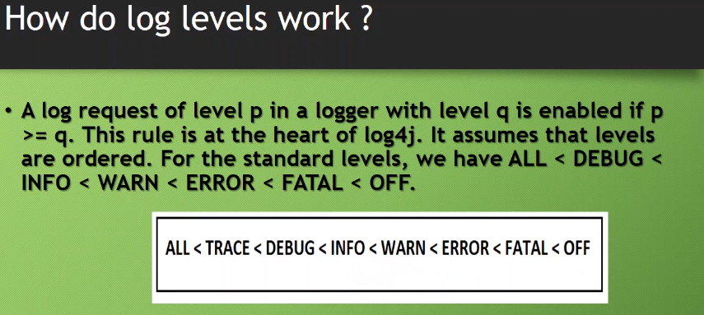

**Appender:**

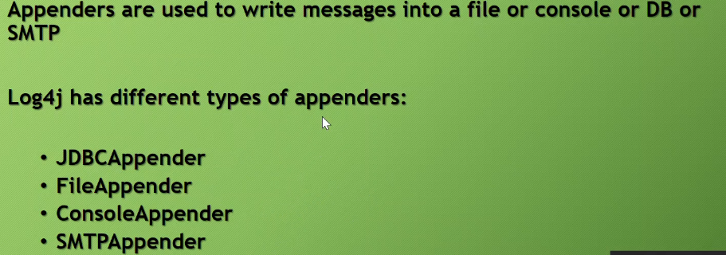

Rolling size Appender helps to roll to new file, based on size or no of lines.

**Layout:**

**Configuration can be done in 4 ways:**

* Basic, using properties file, Xml file or from programmatic.
* Properties file configuration is the widely used in the industry. We load the type of appenders, and layout need to be used in this file.

**Properties file:**

Here log level is DEBUG, means from the DEBUG all higher levels can be printed.

**Class:**

**It is also possible to use both Console and file appenders at same time**

**Log monitoring tools: (**[**Click here for demo**](https://www.youtube.com/watch?v=BUfOuWLgnMU&list=PLpLBSl8eY8jTp72vb1znIbX8egxLuW1yh&index=3)**)**

1. **Win Scp:** To connect to remote system and check logs.
   1. **WinSCP** (Windows Secure Copy) is a free and open-source SFTP, FTP, WebDAV, Amazon S3 and SCP client for Microsoft Windows. Its main function is secure file transfer between a local and a remote computer.
2. **Putty:**
3. **Splunk (Recommended):** To monitor and analyze the logs

**Log4j configuration in java web application:**

[**https://www.youtube.com/watch?v=d9wMvcdUrF4&index=4&list=PLpLBSl8eY8jTp72vb1znIbX8egxLuW1yh**](https://www.youtube.com/watch?v=d9wMvcdUrF4&index=4&list=PLpLBSl8eY8jTp72vb1znIbX8egxLuW1yh)